Chapter Four C#

1. Write a program that **reads** from the console **three numbers** of type **int** and prints their sum.

using System;

namespace _01_readingThree

{

class Program

{

static void Main(string[] args)

{

Console.WriteLine("Shkruaj numrat ");

int num1 = Convert.ToInt32(Console.ReadLine());

int num2 = Convert.ToInt32(Console.ReadLine());

int num3 = Convert.ToInt32(Console.ReadLine());

int sum = num1 + num2 + num3;

Console.WriteLine("Shuma e numrave tuaj eshte {0}", sum);

}

}

}

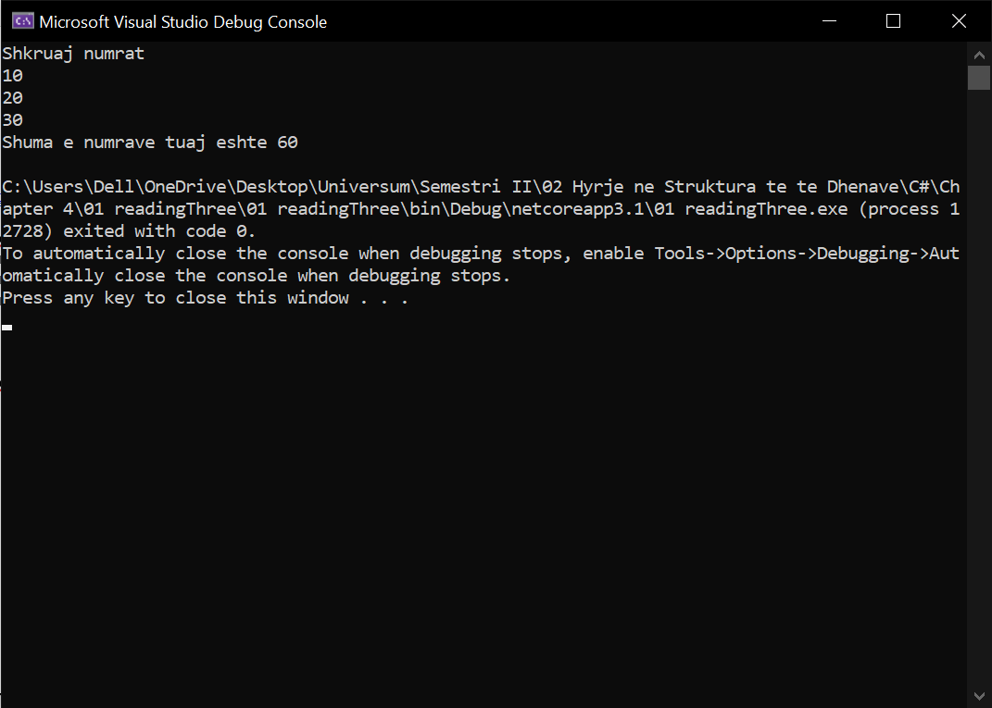

1. Write a program that **reads** from the console the **radius** "**r**" of a circle and prints its **perimeter** **and area**.

using System;

namespace _02_circleArea

{

class Program

{

static void Main(string[] args)

{

double pi = 3.14;

Console.WriteLine("Shkruaj rrezen e rrethit: ");

int r = Convert.ToInt32(Console.Read());

double S = pi * (r ^ 2 );

double P = 2 * pi * r;

Console.WriteLine("Syprina e rrethit eshte {0}, kurse perimetri {1}", S,P);

}

}

}

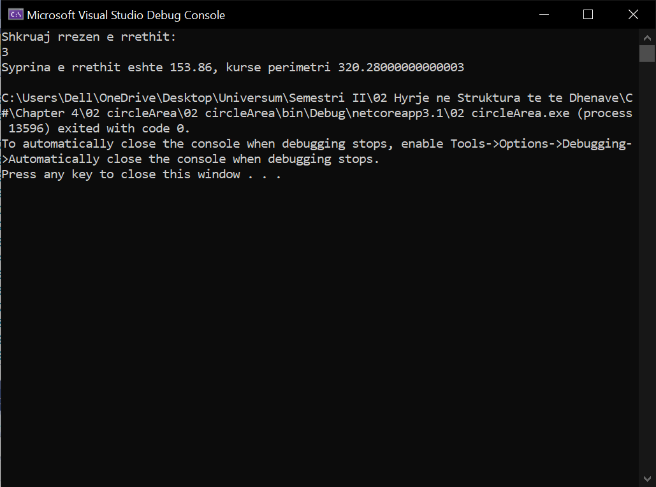

1. A given company has name, address, phone number, fax number, web site and manager. The manager has name, surname and phone number. Write a program that **reads information about the company** and its manager and then **prints it** on the console.

using System;

namespace _03_infoAboutC

{

class Program

{

static void Main(string[] args)

{

Console.WriteLine("Company");

Console.WriteLine("phone : 04444444");

Console.WriteLine("Adress: rruga");

Console.WriteLine("Fax: 1002882028");

Console.WriteLine("Menager: Filan Fisteku");

Console.WriteLine("phone: 04333333");

}

}

}

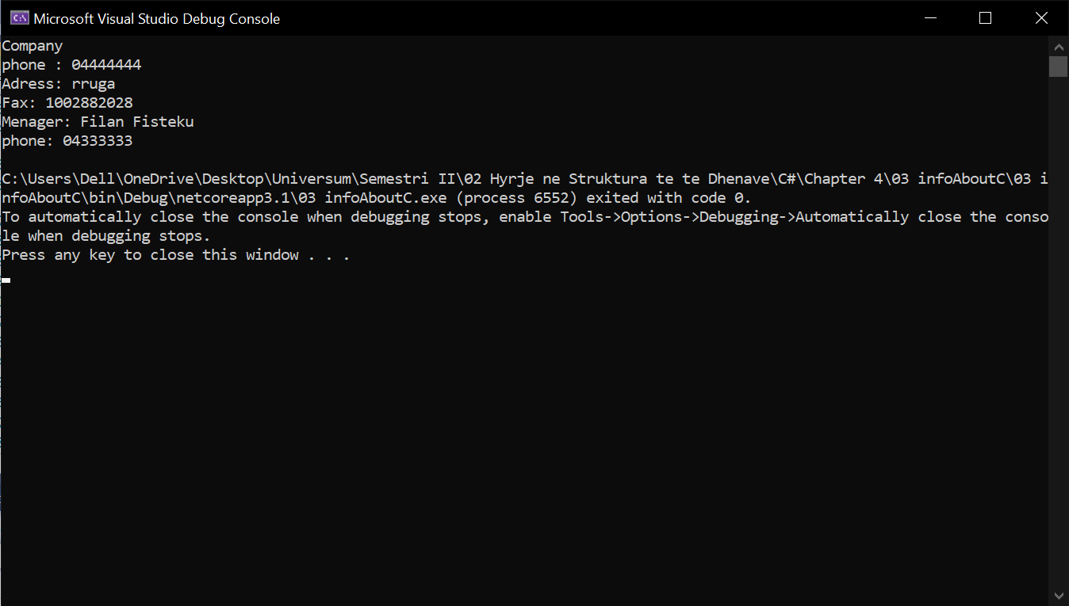

1. Write a program that **prints three numbers in three virtual columns** on the console. Each column should have a width of 10 characters and the numbers should be **left aligned**. The first number should be an integer in **hexadecimal**; the second should be **fractional positive**; and the third – a **negative fraction**. The last two numbers have to be rounded to the second decimal place.

using System;

namespace _04_alignLeft

{

class Program

{

static void Main(string[] args)

{

int hexNum = 2015;

Console.WriteLine("|0x{0,-8:X|", hexNum);

double fractNum = -1.856;

Console.WriteLine("|0,-10:f2}|", fractNum);

}

}

}

1. Write a program that reads from the console two integer numbers (**int**) and prints how many numbers between them exist, such that **the remainder of their division by 5 is 0**. Example: in the range (14, 25) there are 3 such numbers: 15, 20 and 25.

using System;

namespace _05_checkingEvery5

{

class Program

{

static void Main(string[] args)

{

int counter = 0;

Console.Write("Write the first number: ");

int a = Convert.ToInt32(Console.ReadLine());

Console.Write("Write the second number: ");

int b = Convert.ToInt32(Console.ReadLine());

for(int i = a; i <= b; i++)

{

if (i % 5 == 0) counter++;

}

Console.WriteLine("{0} numbers found.", counter);

}

}

}

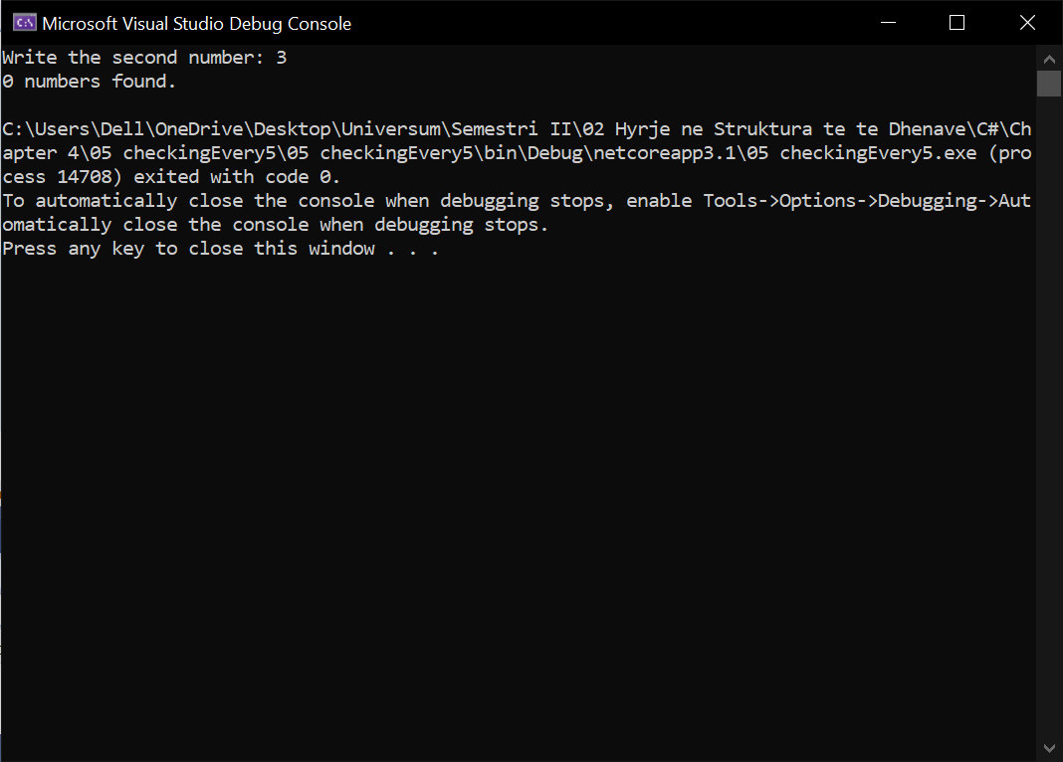

1. Write a program that reads two numbers from the console and **prints the greater of them**. Solve the problem without using conditional statements.

using System;

namespace _06_greaterThen

{

class Program

{

static void Main(string[] args)

{

Console.WriteLine("Shkruaj Numrat: ");

int a = Convert.ToInt32(Console.ReadLine());

int b = Convert.ToInt32(Console.ReadLine());

Console.WriteLine("{0} > {1}", Math.Max(a, b), Math.Min(a, b));

}

}

}

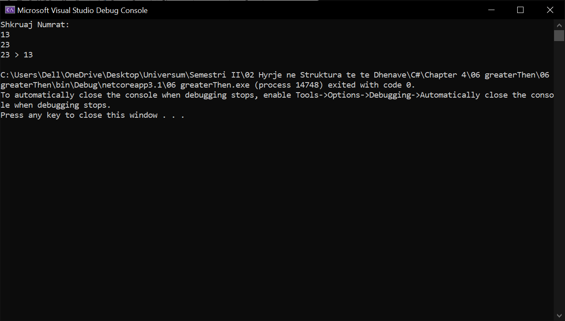

1. Write a program that **reads five integer numbers and prints their sum**. If an invalid number is entered the program should prompt the user to enter another number.

using System;

namespace _07_readingFive

{

class Program

{

static void Main(string[] args)

{

int a, b, c, d, e;

bool parseSucceed = false;

do

{

Console.Write("Enter first number");

parseSucceed = Int32.TryParse(Console.ReadLine(), out a);

Console.WriteLine(parseSucceed);

} while (!parseSucceed);

do

{

Console.Write("Enter second number");

parseSucceed = Int32.TryParse(Console.ReadLine(), out b);

Console.WriteLine(parseSucceed);

} while (!parseSucceed);

do

{

Console.Write("Enter third number");

parseSucceed = Int32.TryParse(Console.ReadLine(), out c);

Console.WriteLine(parseSucceed);

} while (!parseSucceed);

do

{

Console.Write("Enter fourth number");

parseSucceed = Int32.TryParse(Console.ReadLine(), out d);

Console.WriteLine(parseSucceed);

} while (!parseSucceed);

do

{

Console.Write("Enter fifth number");

parseSucceed = Int32.TryParse(Console.ReadLine(), out e);

Console.WriteLine(parseSucceed);

} while (!parseSucceed);

}

}

}

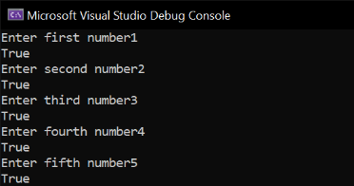

1. Write a program that reads five numbers from the console and prints the **greatest** of them.

using System;

namespace ConsoleApp1

{

class Program

{

static void Main(string[] args)

{

Console.Write("Shkruaj numrin e par: ");

int a = int.Parse(Console.ReadLine());

Console.Write("Shkruaj numrin e dyt: ");

int b = int.Parse(Console.ReadLine());

Console.Write("Shkruaj numrin e tret: ");

int c = int.Parse(Console.ReadLine());

if (a > b)

if (a > c) Console.WriteLine("A is the biggest");

else if (a < c) Console.WriteLine("C is the biggest");

else Console.WriteLine("A and C are the biggest");

else if (a < b)

if (b > c) Console.WriteLine("B is the biggest");

else if (b < c) Console.WriteLine("C is the biggest");

else Console.WriteLine("B and C are the biggest");

else if (a == b)

if (a == c) Console.WriteLine("All are equal");

else if (a < c) Console.WriteLine("C is the biggest");

else Console.WriteLine("A and B are the biggest");

}

}

}

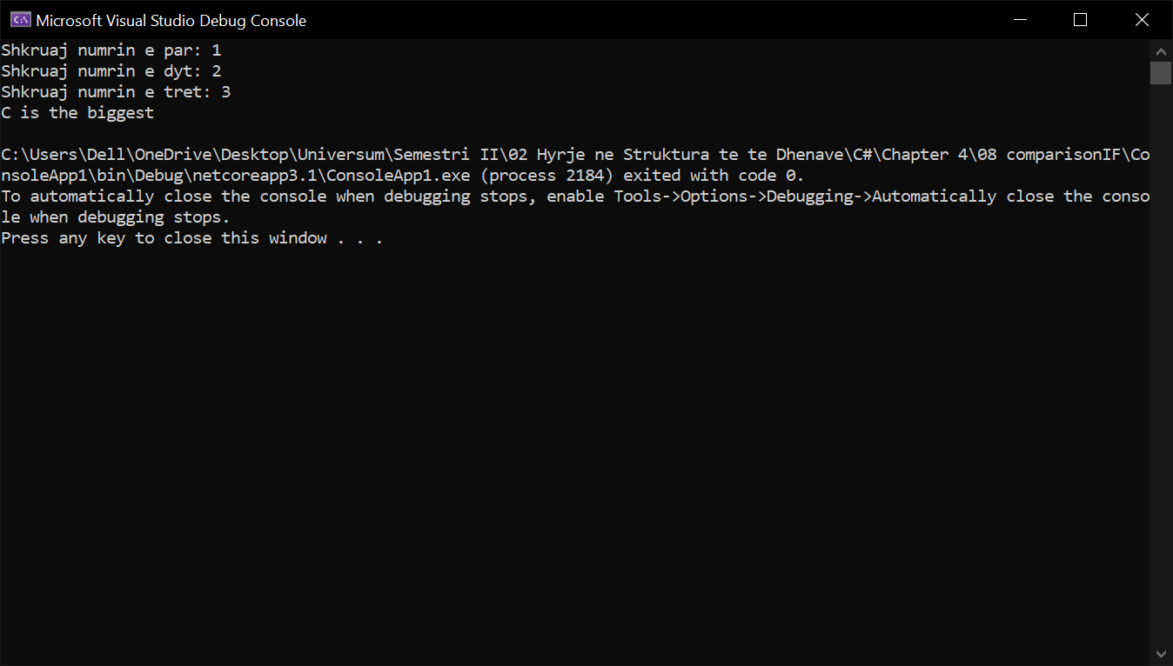

1. Write a program that reads an integer number **n** from the console. After that reads **n** numbers from the console and prints their **sum**.

using System;

namespace _09_readinIntegeraddinSum

{

class Program

{

static void Main(string[] args)

{

double d, x1, x2;

Console.Write("Enter A (A != 0): ");

double a = Int32.Parse(Console.ReadLine());

Console.Write("Enter B: ");

double b = Int32.Parse(Console.ReadLine());

Console.Write("Enter C: ");

double c = Int32.Parse(Console.ReadLine());

d = b * b - 4 * a * c;

if (d < 0) Console.WriteLine("D={0}, There are no real roots.", d);

else if (d == 0)

{

x1 = (-b / (2 * a));

Console.WriteLine("X={0}", x1);

}

else

{

x1 = (-b + Math.Sqrt(d)) / (2 * a);

x2 = (-b - Math.Sqrt(d)) / (2 * a);

Console.WriteLine("X1={0}, X2={1}", x1, x2);

}

}

}

}

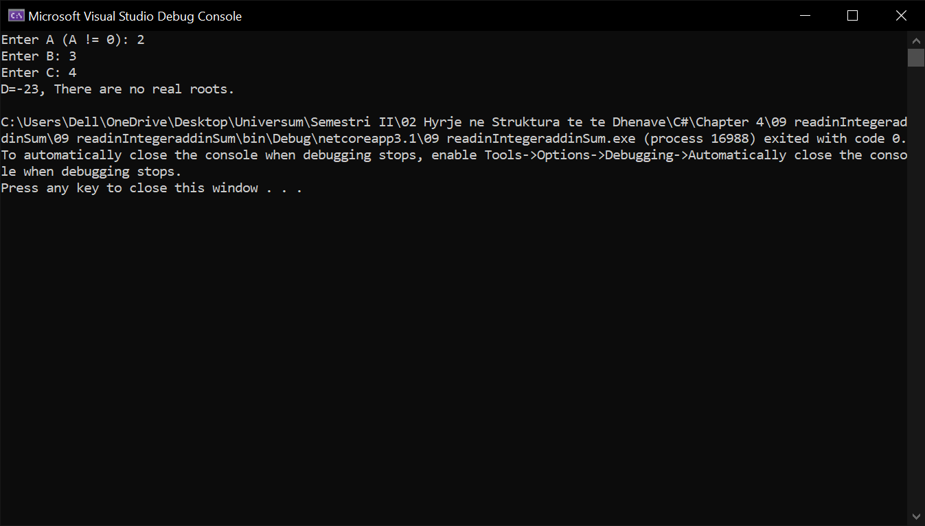

1. Write a program that reads an integer number **n** from the console and **prints** **all numbers in the range** **[1…n]**, each on a separate line.

using System;

namespace _10_countingRange

{

class Program

{

static void Main(string[] args)

{

int sum = 0;

Console.Write("Enter numbers count: ");

int length = Int32.Parse(Console.ReadLine());

for (int i = 0; i < length; i++)

{

Console.Write("Enter {0} number: ", i + 1);

sum += Int32.Parse(Console.ReadLine());

}

Console.WriteLine("Sum of all numbers is {0}.", sum);

}

}

}

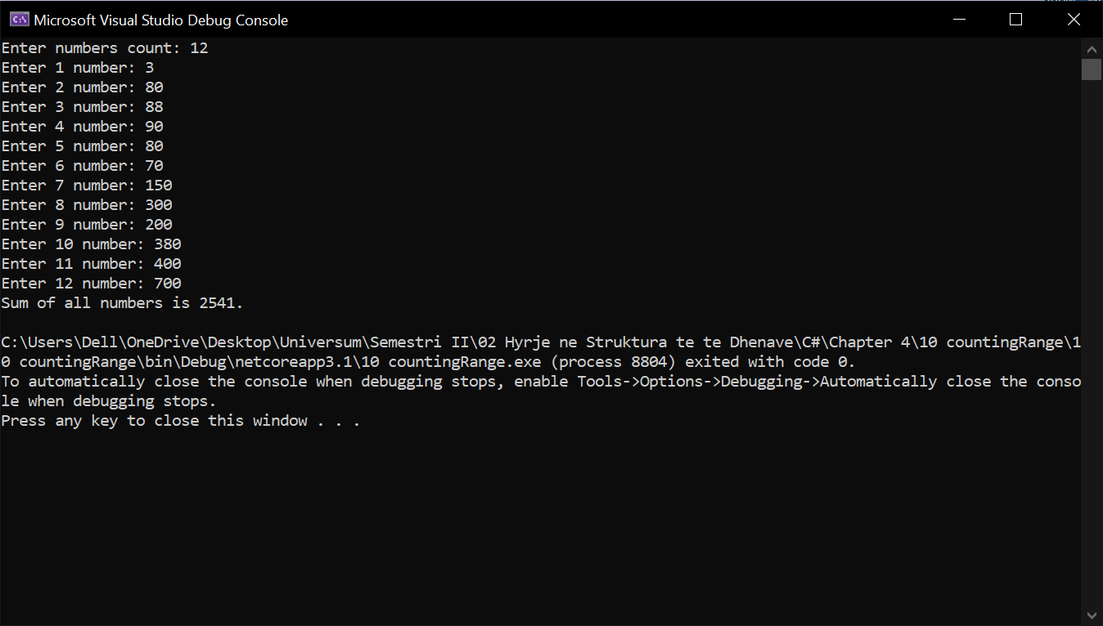

1. Write a program that prints on the console the first 100 numbers in the **Fibonacci sequence**: 0, 1, 1, 2, 3, 5, 8, 13, 21, 34, 55, 89, 144, 233, …

using System;

namespace _11_lengthIneger

{

class Program

{

static void Main(string[] args)

{

Console.WriteLine("Enter a number");

int count = Convert.ToInt32(Console.ReadLine());

for(int i = 1; i <= count; i++)

{

Console.WriteLine(i);

}

}

}

}

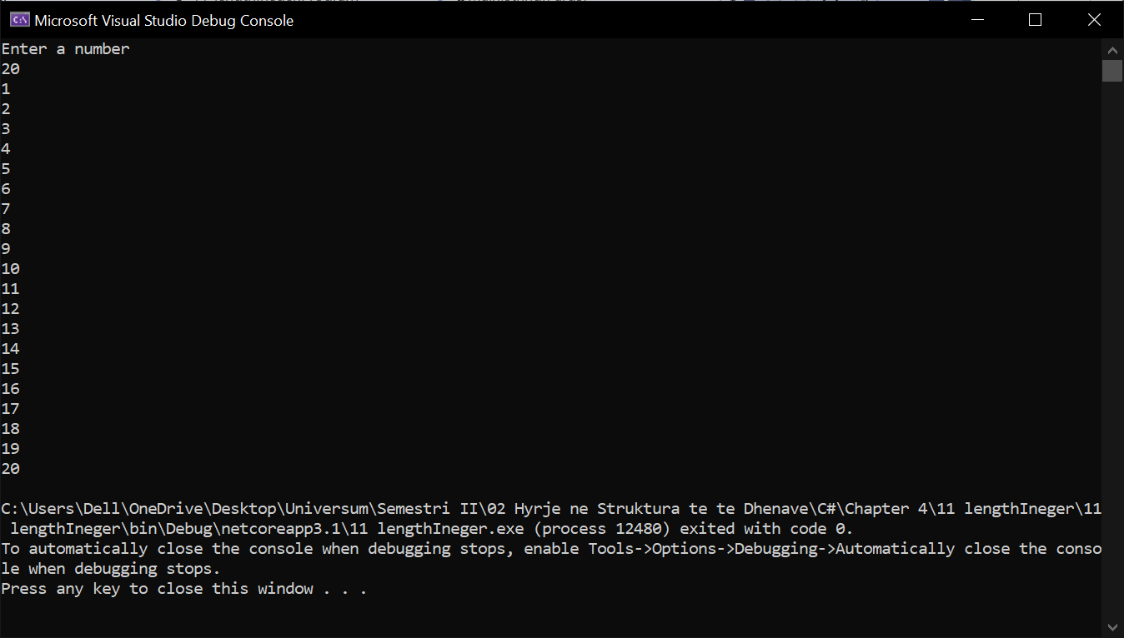

1. Write a program that calculates the **sum** (with **precision of 0.001**) of the following sequence: 1 + 1/2 - 1/3 + 1/4 - 1/5 + …

using System;

namespace _12_sequenceNumbers

{

class Program

{

static void Main(string[] args)

{

Console.Write("Enter last number: ");

int length = Int32.Parse(Console.ReadLine());

double sum = 1.0;

for (int i = 2; i <= length; i++)

{

sum += (1.0 / i);

}

Console.WriteLine("{0:F3}", sum);

}

}

}

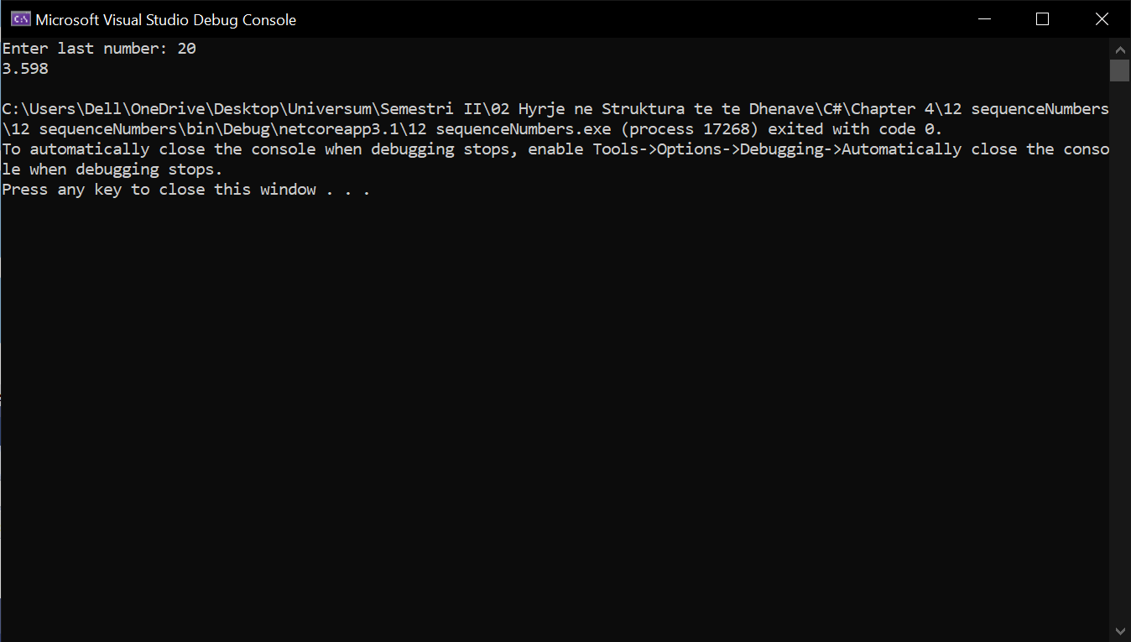

Enis Neziri, Ferizaj 2021.